Practical No. :- 2 Date :- 02/12/2023
Q.) Fit a binomial distribution.
X | F
0 | 14
1 | 62
2 | 46
3 | 10
4 | 4
Solution :-
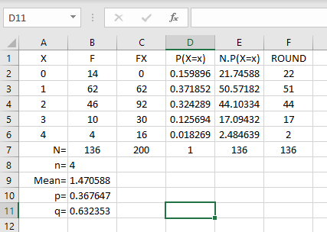

Formula used :-
- FX =A2*B2 , Sum =SUM(C2:C6)
- P(X=x) =BINOMDIST(A2,$A$6,$B$10,FALSE) , Sum =SUM(D2:D6)
- N.P(X=x) =$B$7*D2 , Sum =SUM(E2:E6)
- Round =ROUND(E2,0) , Sum =SUM(F2:F6)
- N =SUM(B2:B6)
- Mean =C7/B7
- P =B9/B8
- q =1-B10

Practical No. :- 3 Date :- 02/13/2023
Q.) From the Following data
X | F
0 | 14
1 | 62
2 | 46
3 | 10
4 | 4
Calculate :-
- P(X=1)
- P(x<=1)
- P(1<X<4)
- P(1<=X<4)
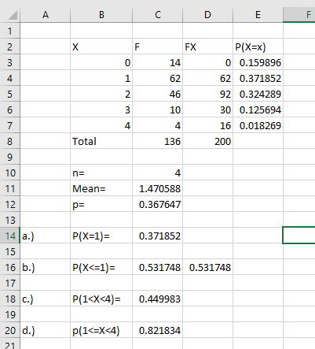
Solution :-

Formula used :-
FX =B3*C3 , Sum =SUM(D3:D7)
P(X=x) =BINOMDIST(B3,$B$7,$C$12,FALSE)
Mean =D8/C8
P =C11/C10
Total =SUM(C3:C7)

- P(X=1) =BINOMDIST(1,C10,C12,FALSE)
- P(X<=1) =BINOMDIST(0,4,C12,FALSE)+BINOMDIST(1,4,C12,FALSE) / =BINOMDIST(1,4,C12,TRUE)
- P(1<X<4) =E5+E6
- P(1<=X<4) =E4+E5+E6
Practical No. :- 5
Q.) From the following data Date :- 02/14/2023
X | F
0 | 14
1 | 62
2 | 46
3 | 10
4 | 4

Calculate :-
- P(X=2)
- P(X<=2)
- P(X>2)
Solution :-
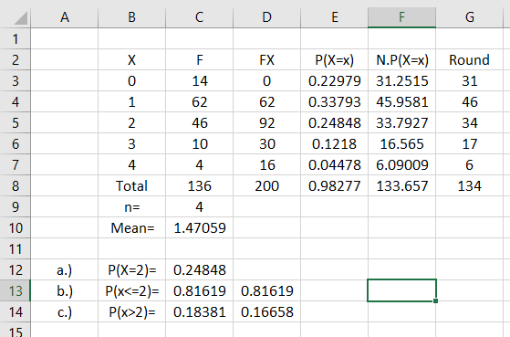
Formula Used :-
FX =B3*C3 , Sum =SUM(D3:D7)

P(X=x) =POISSON.DIST(B3,$C$10,FALSE) ,
Sum =SUM(E3:E7)

N.P(X=x) =$C$8*E3
Sum =SUM(F3:F7)

Round =ROUND(F3,0)
Sum =SUM(G3:G7)

Formula Used :-
- P(X=2) =POISSON.DIST(2,C10,FALSE)
- P(X<=2) =POISSON.DIST(2,C10,TRUE) , =E3+E4+E5
- P(X>2) =1-POISSON.DIST(2,C10,TRUE) , =E6+E7

Parctical No. No : - 15 Date :- 02/17/2023
Q.) From the following data ,
a.) Determine the regression equation of processed request (Y) on data Size (X)
b.) Interppret the regression Coefficient
c.) Calculate the coefficient of determinant and interpret the result
d.) Predict the value of processed request when data size is 9
e.) Calculate the standard error of estiminate and interpret the result.
Data Size (X) | 6 | 7 | 7 | 8 | 10 | 10 | 15
Prodcessed requiest (Y) | 40 | 55 | 50 | 41 | 17 | 26 | 16

Solution :-
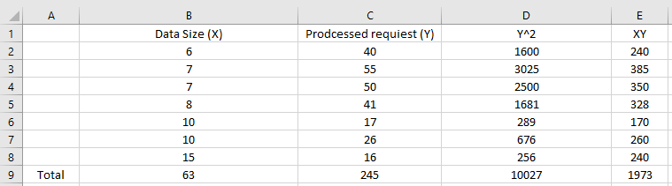
a.)
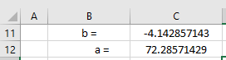
Regression eqn of Y on X is
Y = a+bx
Y(cap) = 72.24 – 4.14* X
Formula used :-
b =SLOPE(C2:C8,B2:B8) , a =INTERCEPT(C2:C8,B2:B8)

b.)
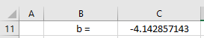
When data size (X) increases by 1 unit then processed reuest will decreases by 4.14 unit.

c.)
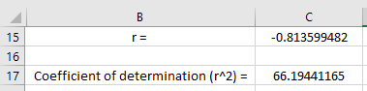
Formula used : -
r =CORREL(B2:B8,C2:C8)
Change in processed requite (Y) is due to changein data size (X) is 66.19 % and remaining 33.81% is due to other factors.

d.)
Y(cap) = 72.28-4.14*X
Where x =9
Y(cap) = 72.28-4.14*9 = 35
e.)
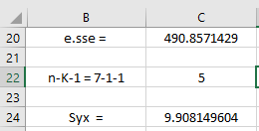
formula used :-
e.sse =D9-C12*C9-(C11)*E9
Syx =SQRT(C20/C22)
Average variation of the given points from the fitted line ( regression line ) is 9.90
Practical No. :- 4 Date :- 02/13/2023
Q.) Fit a poisson distribution
X | F
0 | 14
1 | 62
2 | 46
3 | 10
4 | 4
Solution :-

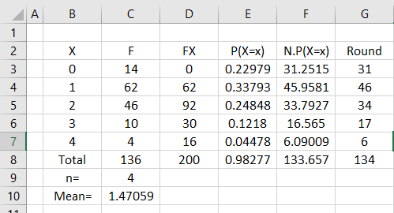

Formula used :-
- P(X=x) =POISSON.DIST(B3,$C$10,FALSE)
- N.P(X=x) =$C$8*E3
- Round =ROUND(F3,0)
- Mean (x) =D8/C8

